Graduated Cylinder
# Source: AI Source: Provided by: [Data Path: Persons Table -> ID Column: 1, Name_En Column: Motasem Essam] -> From: [ChatGPT] on [7/17/2026]
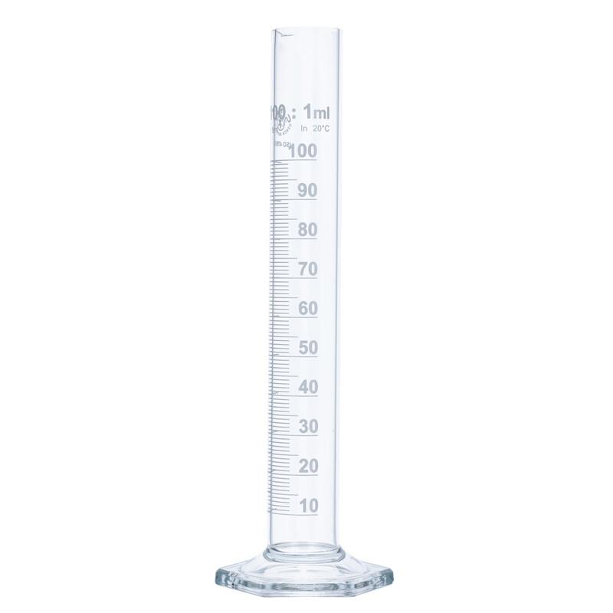
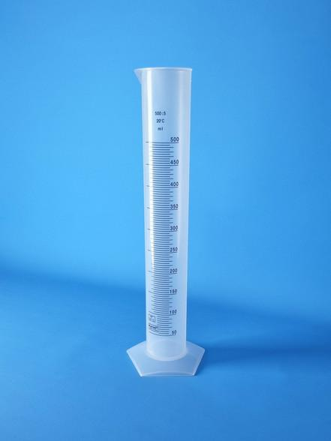
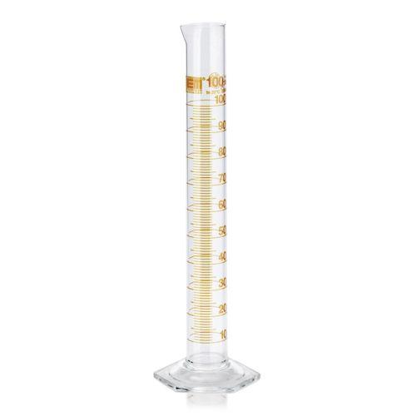
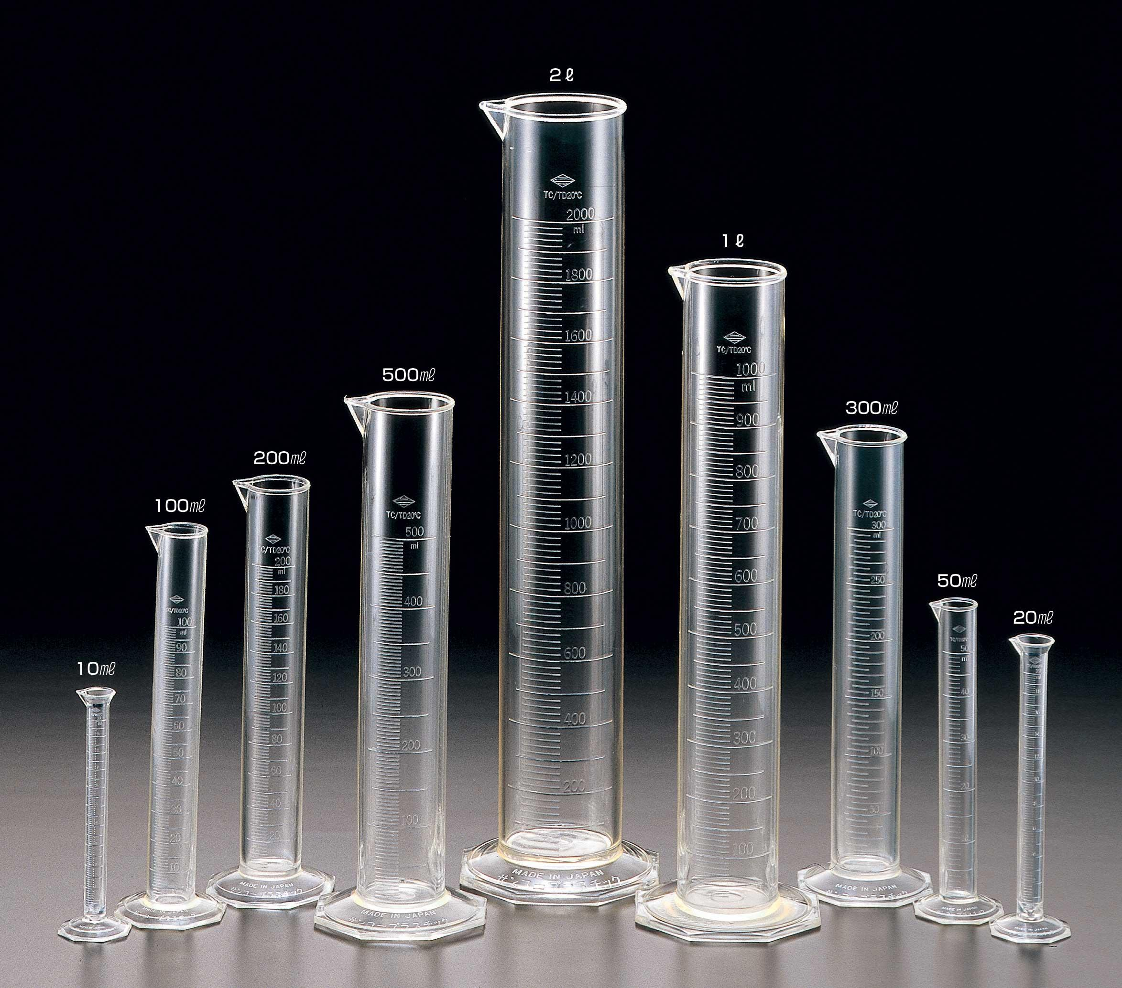
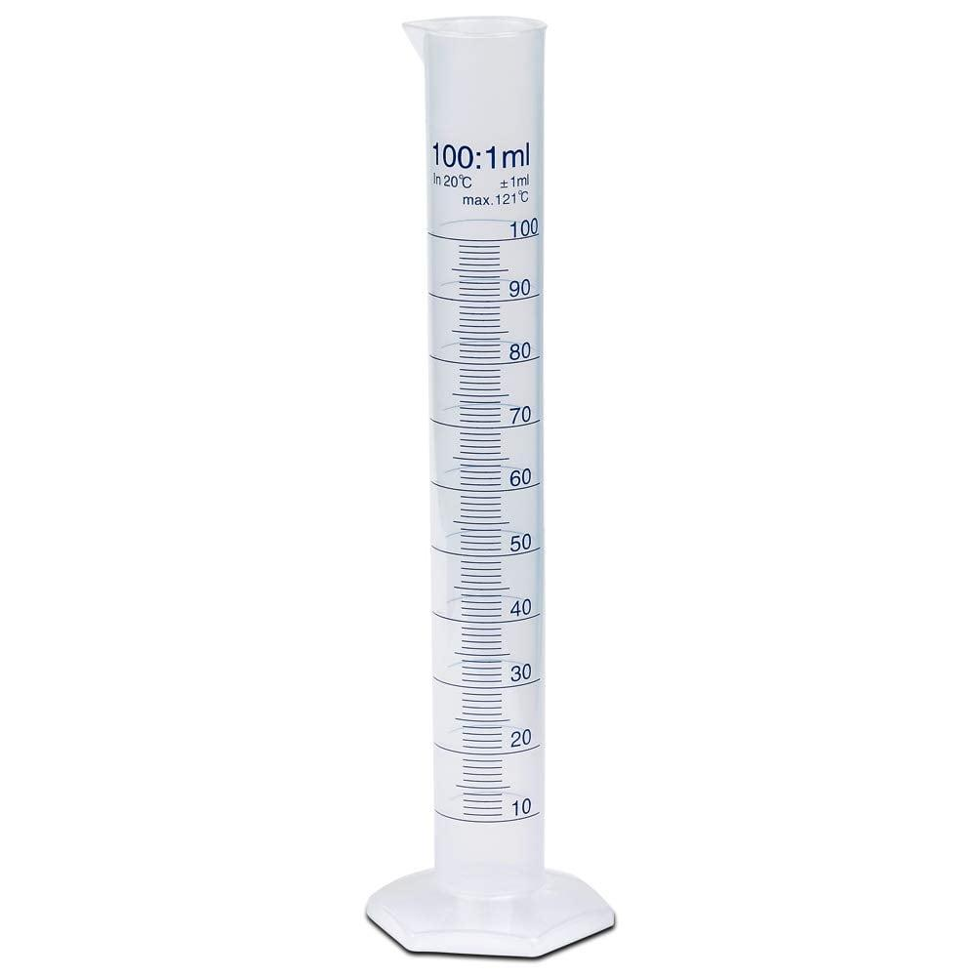
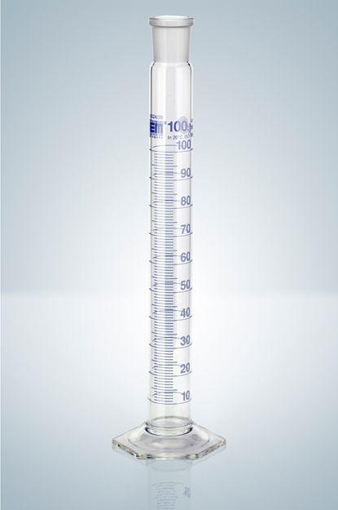
A Graduated Cylinder (also called a Measuring Cylinder) is a laboratory volume-measuring instrument used to accurately measure the volume of liquids. It is more accurate than a beaker or measuring cup but less accurate than a volumetric flask or pipette.
Graduated cylinders are widely used in chemistry, biology, physics, medicine, pharmaceuticals, education, food science, and industrial laboratories.

Definition
# Source: AI Source: Provided by: [Data Path: Persons Table -> ID Column: 1, Name_En Column: Motasem Essam] -> From: [ChatGPT] on [7/17/2026]
A Graduated Cylinder is a cylindrical laboratory instrument marked with graduated volume scales for accurately measuring the volume of liquids.

Purpose
# Source: AI Source: Provided by: [Data Path: Persons Table -> ID Column: 1, Name_En Column: Motasem Essam] -> From: [ChatGPT] on [7/17/2026]
A graduated cylinder is used to:
- Measure liquid volume.
- Transfer known liquid quantities.
- Prepare chemical solutions.
- Measure displacement volume of irregular solids.
- Conduct laboratory experiments.
- Verify liquid quantities.

Principle of Operation
# Source: AI Source: Provided by: [Data Path: Persons Table -> ID Column: 1, Name_En Column: Motasem Essam] -> From: [ChatGPT] on [7/17/2026]
A graduated cylinder measures volume by comparing the liquid level with calibrated graduation marks.
The correct reading is taken at the bottom of the meniscus for most transparent liquids (such as water).

Main Components
# Source: AI Source: Provided by: [Data Path: Persons Table -> ID Column: 1, Name_En Column: Motasem Essam] -> From: [ChatGPT] on [7/17/2026]
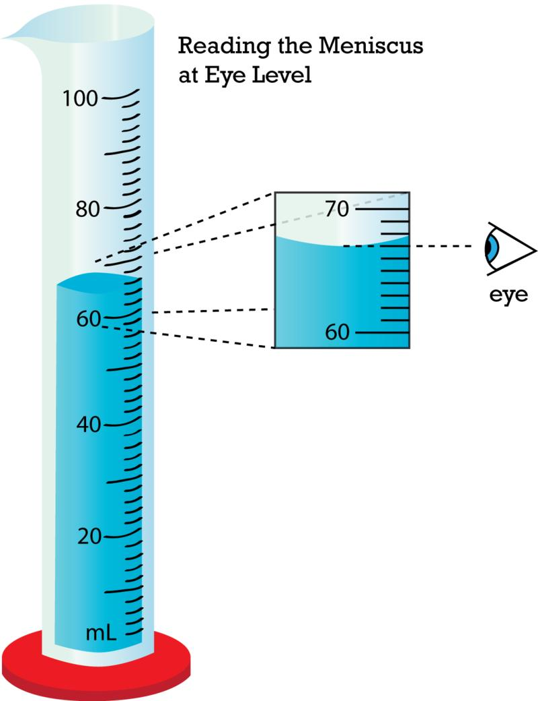
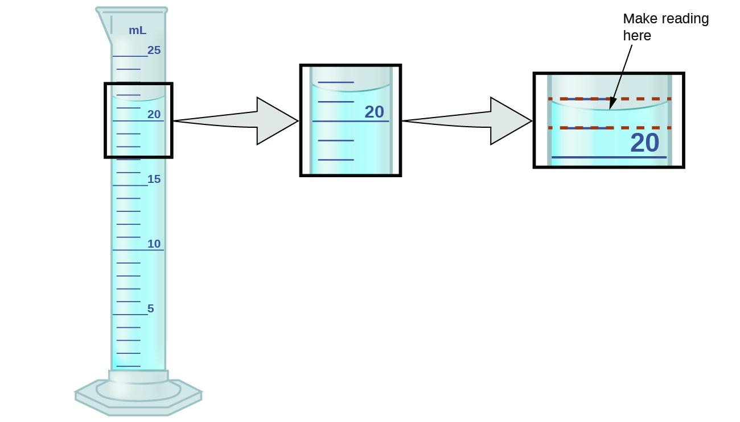
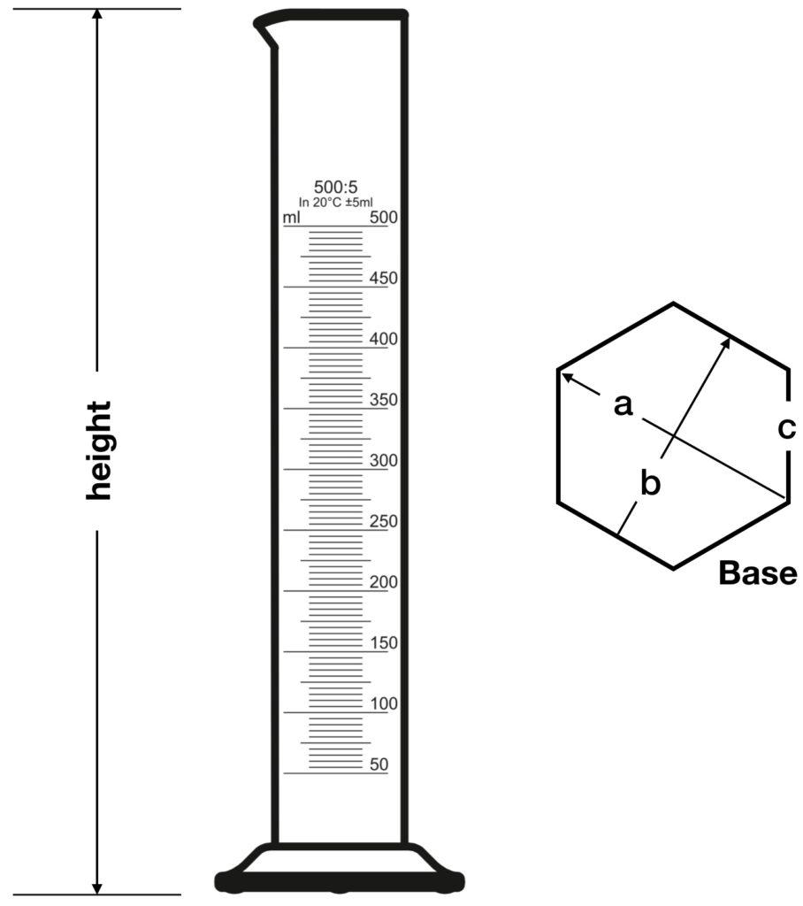
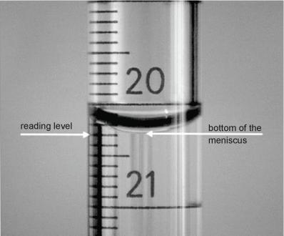
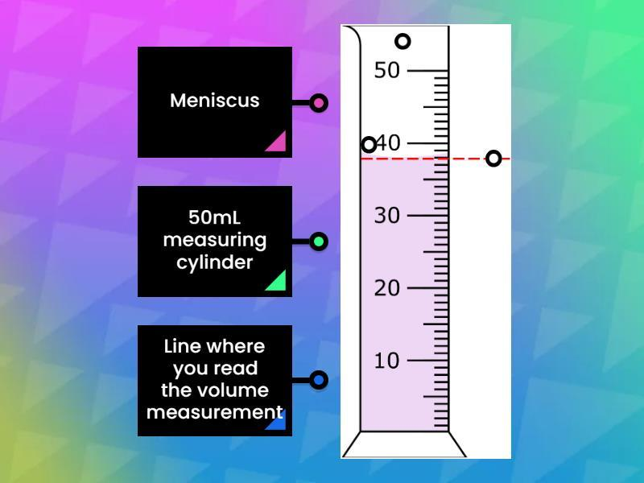
A graduated cylinder typically consists of:
- Cylindrical body
- Graduation scale
- Pouring spout
- Stable base
- Calibration markings

Types of Graduated Cylinders

1. Glass Graduated Cylinder
# Source: AI Source: Provided by: [Data Path: Persons Table -> ID Column: 1, Name_En Column: Motasem Essam] -> From: [ChatGPT] on [7/17/2026]
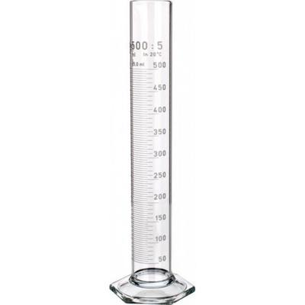
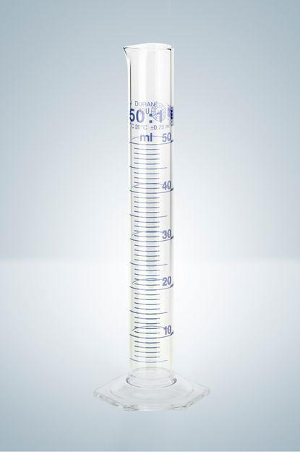
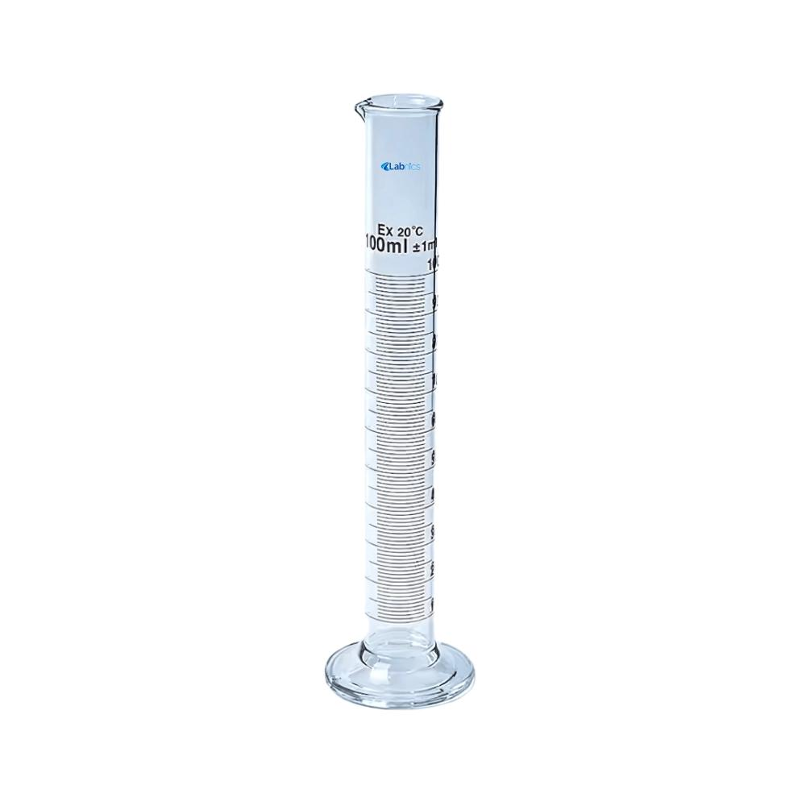
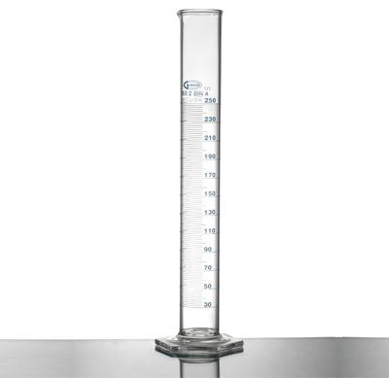
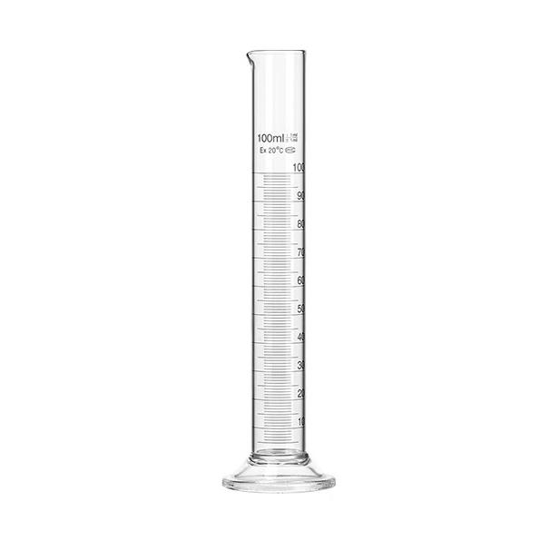
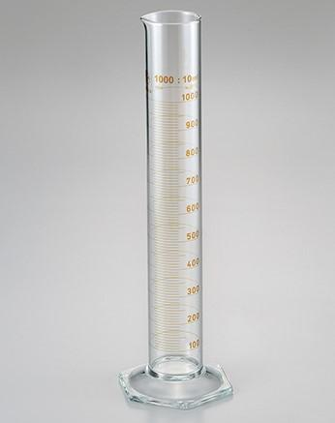
Description
Made from borosilicate glass.
Features
- Chemically resistant
- Heat resistant
- High accuracy
- Transparent
Applications
- Chemistry laboratories
- Pharmaceutical laboratories
- Research

2. Plastic Graduated Cylinder
# Source: AI Source: Provided by: [Data Path: Persons Table -> ID Column: 1, Name_En Column: Motasem Essam] -> From: [ChatGPT] on [7/17/2026]
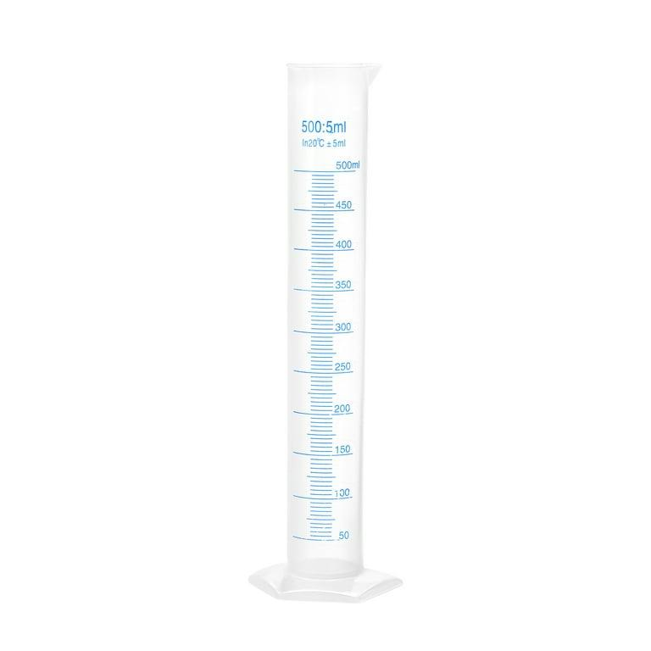
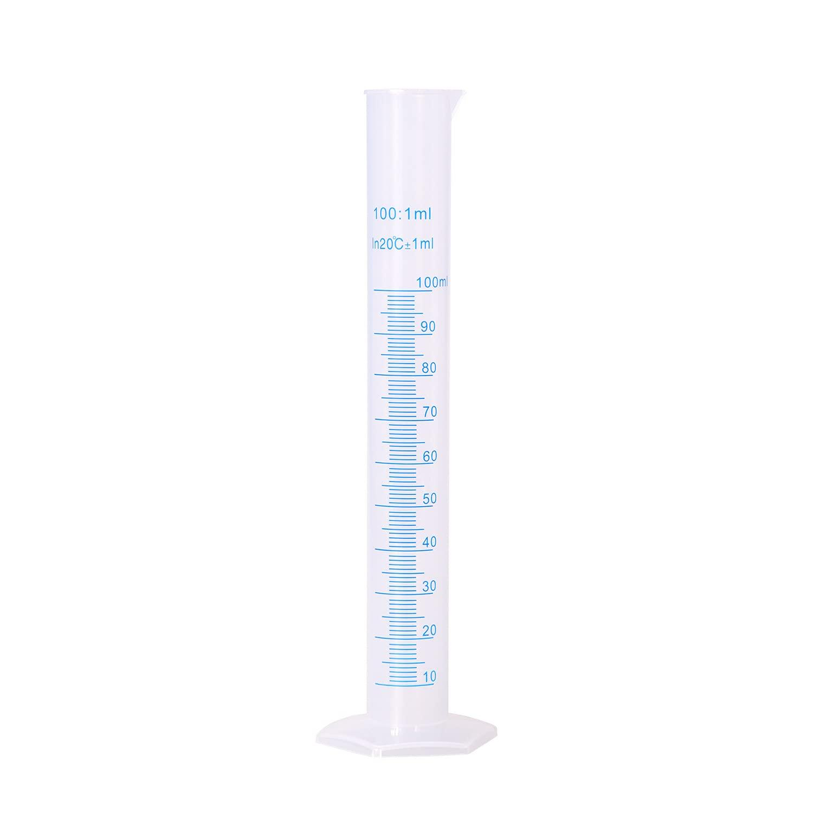
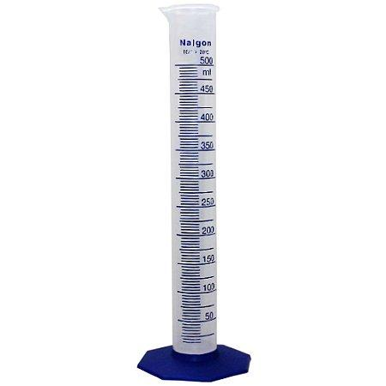
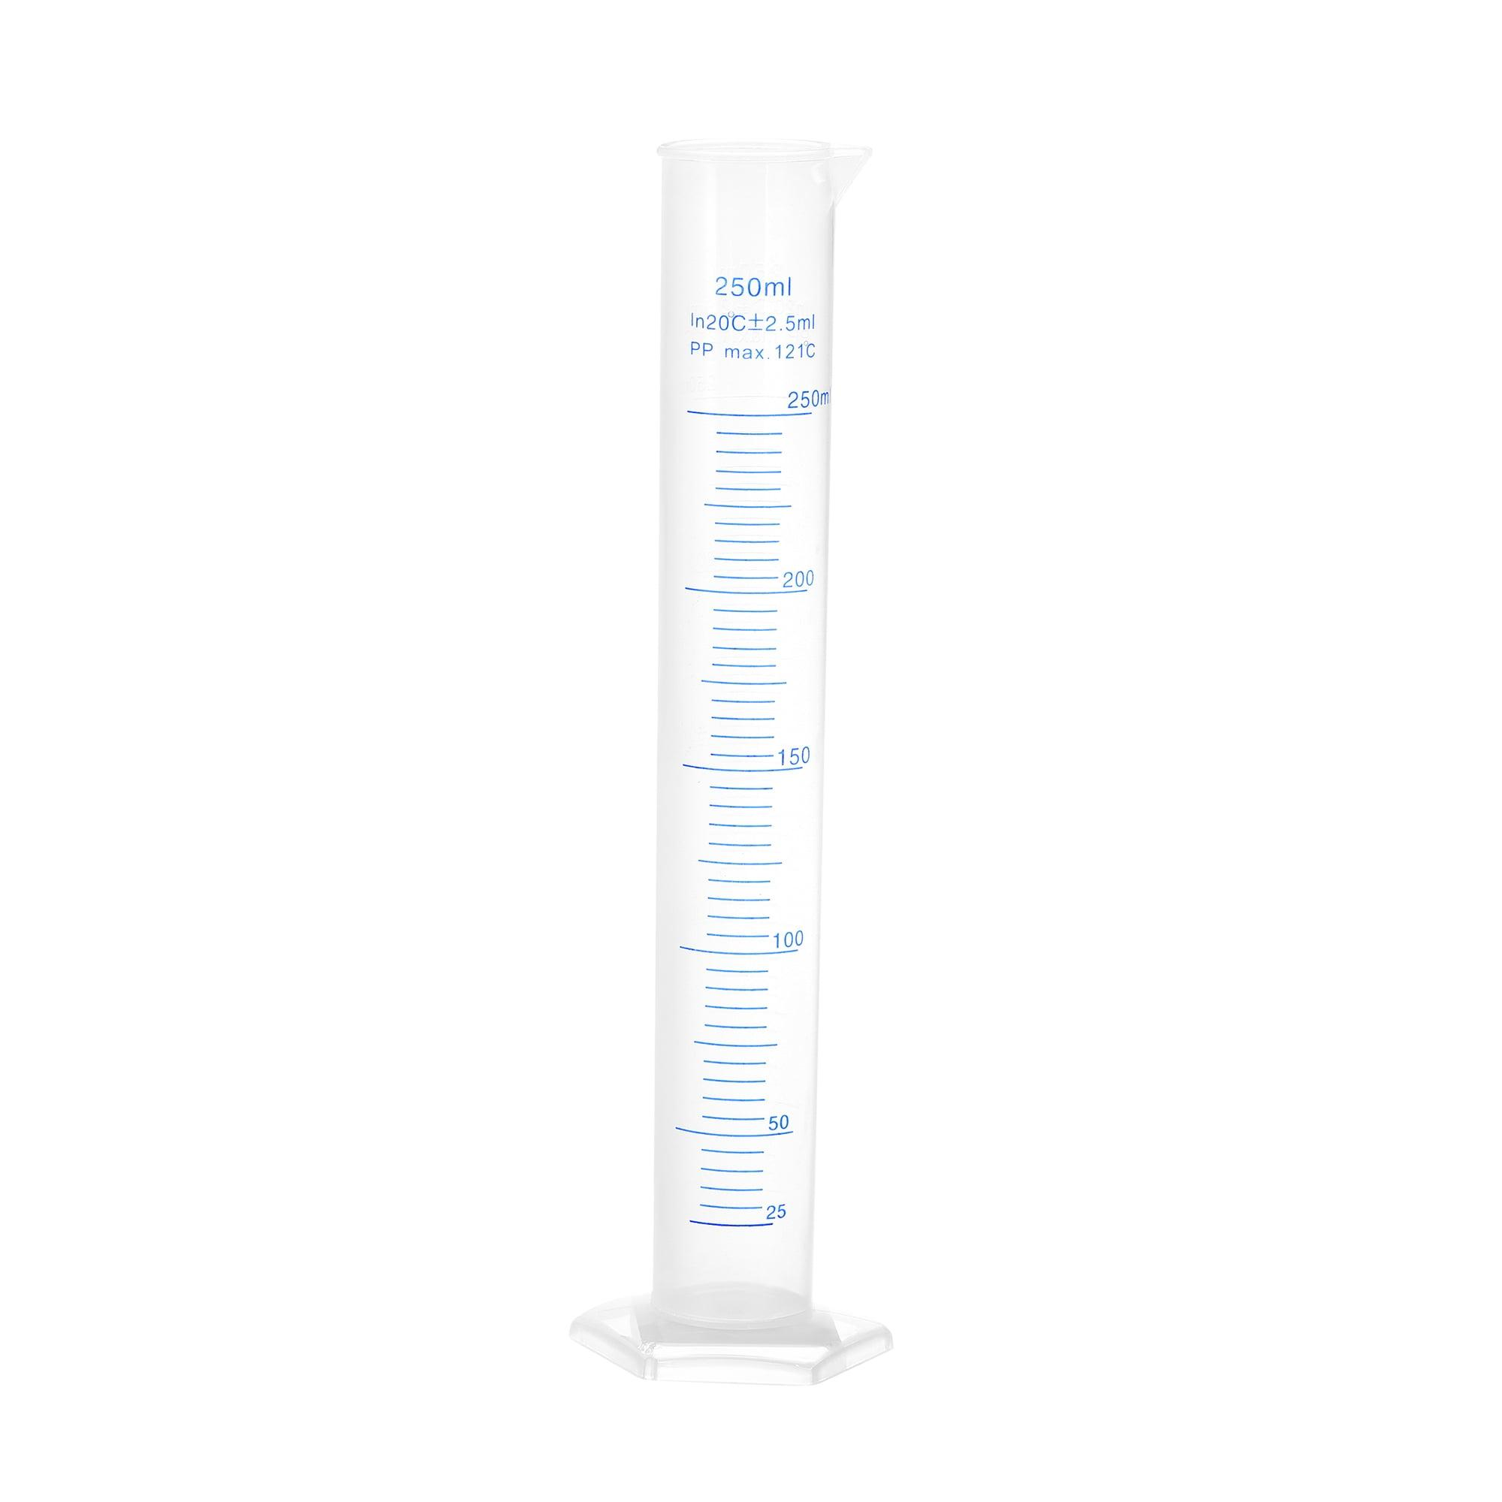
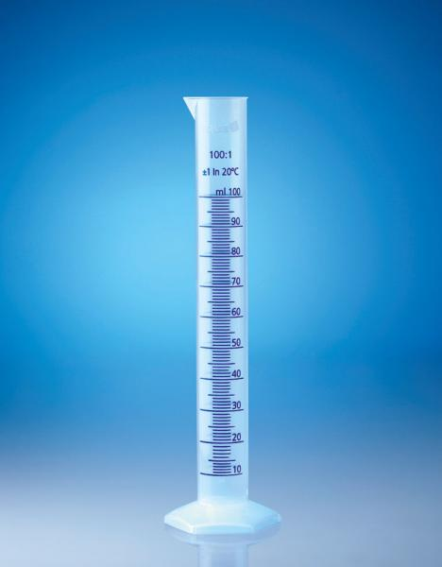
Description
Made from polypropylene or similar plastics.
Features
- Lightweight
- Break resistant
- Affordable
Applications
- Schools
- Educational laboratories
- Field work

3. Hexagonal Base Graduated Cylinder
# Source: AI Source: Provided by: [Data Path: Persons Table -> ID Column: 1, Name_En Column: Motasem Essam] -> From: [ChatGPT] on [7/17/2026]
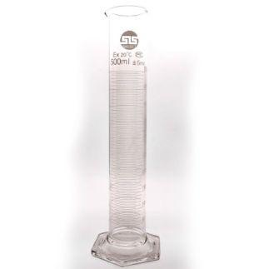

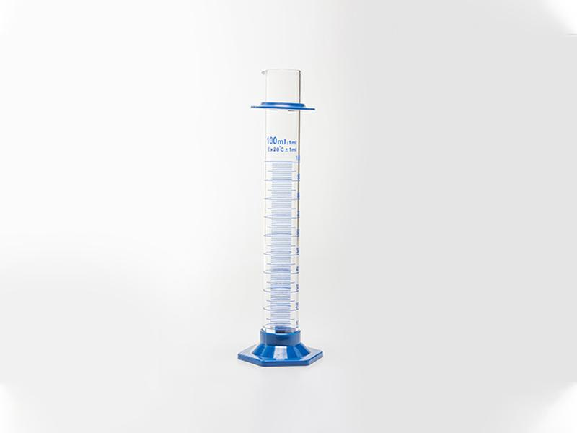
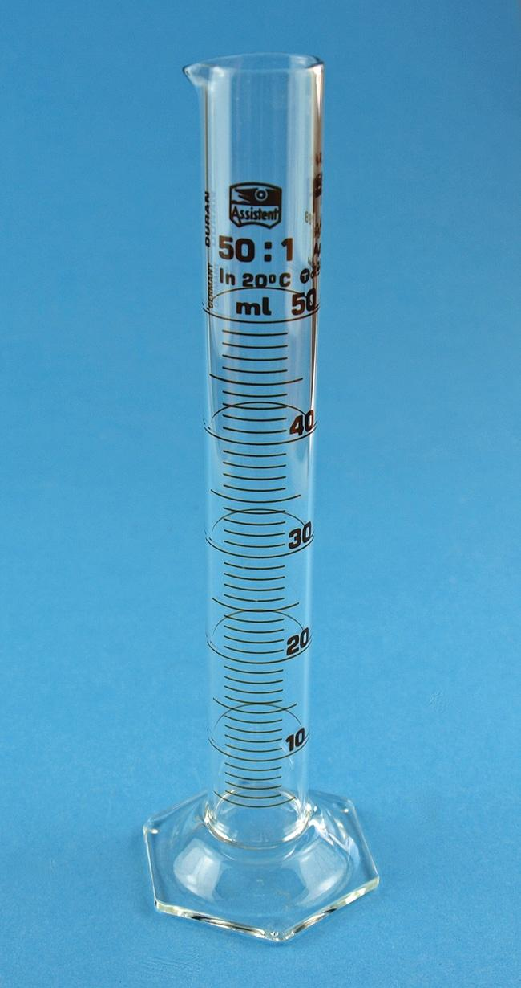

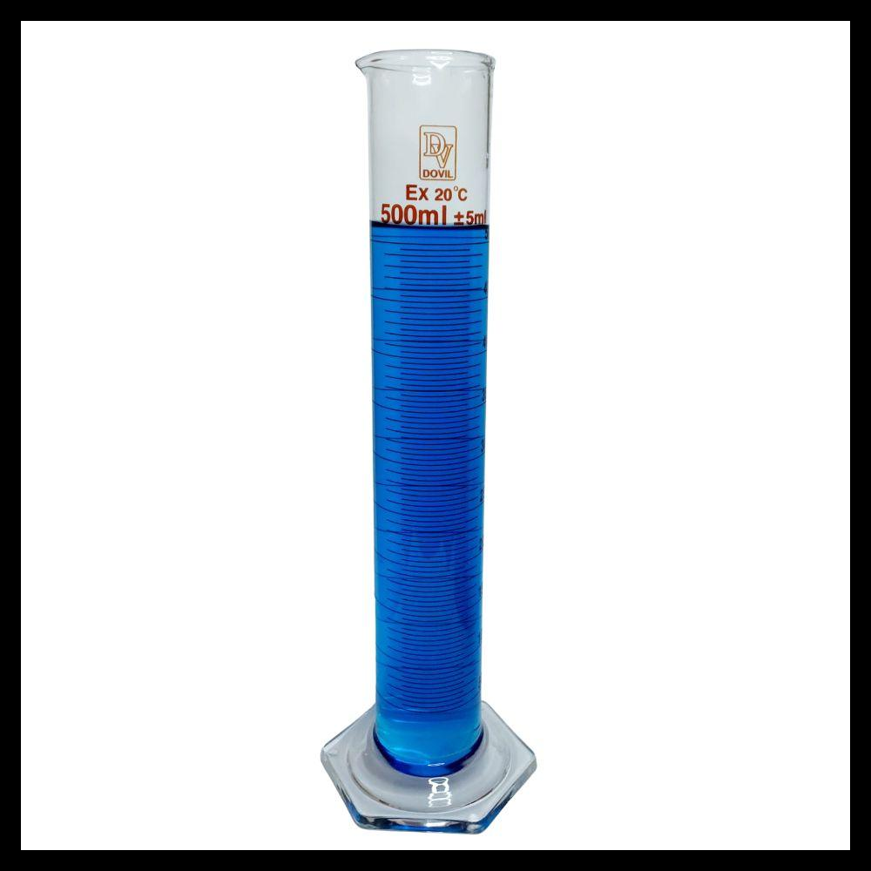
Description
Designed with a hexagonal base to improve stability.
Applications
- General laboratory work
- Student laboratories

Common Capacities
# Source: AI Source: Provided by: [Data Path: Persons Table -> ID Column: 1, Name_En Column: Motasem Essam] -> From: [ChatGPT] on [7/17/2026]
Typical graduated cylinders are available in:
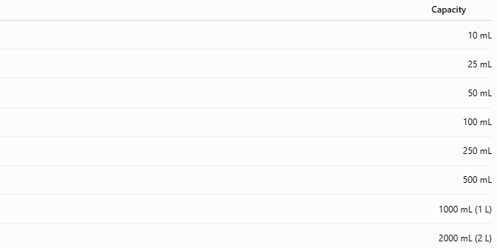
Capacity
10 mL
25 mL
50 mL
100 mL
250 mL
500 mL
1000 mL (1 L)
2000 mL (2 L)

Measuring Units
# Source: AI Source: Provided by: [Data Path: Persons Table -> ID Column: 1, Name_En Column: Motasem Essam] -> From: [ChatGPT] on [7/17/2026]
Graduated cylinders typically use:
- Milliliters (mL)
- Liters (L)

Resolution
# Source: AI Source: Provided by: [Data Path: Persons Table -> ID Column: 1, Name_En Column: Motasem Essam] -> From: [ChatGPT] on [7/17/2026]
Resolution depends on cylinder size.
Typical values:
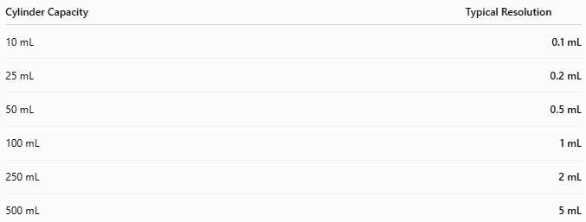
Cylinder Capacity | Typical Resolution
10 mL | 0.1 mL
25 mL | 0.2 mL
50 mL | 0.5 mL
100 mL | 1 mL
250 mL | 2 mL
500 mL | 5 mL

Measuring Range
# Source: AI Source: Provided by: [Data Path: Persons Table -> ID Column: 1, Name_En Column: Motasem Essam] -> From: [ChatGPT] on [7/17/2026]
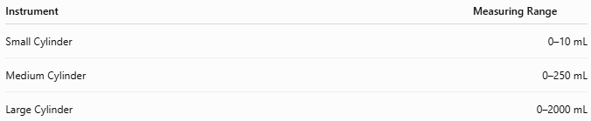
Instrument | Measuring Range
Small Cylinder | 0–10 mL
Medium Cylinder | 0–250 mL
Large Cylinder | 0–2000 mL

How to Read a Graduated Cylinder
# Source: AI Source: Provided by: [Data Path: Persons Table -> ID Column: 1, Name_En Column: Motasem Essam] -> From: [ChatGPT] on [7/17/2026]
- Place the cylinder on a flat, level surface.
- Pour the liquid carefully.
- Allow the liquid to settle.
- Bend to eye level.
- Read the bottom of the meniscus.
For opaque liquids or those with unusual menisci, follow the relevant laboratory procedure.

Example
# Source: AI Source: Provided by: [Data Path: Persons Table -> ID Column: 1, Name_En Column: Motasem Essam] -> From: [ChatGPT] on [7/17/2026]
A 100 mL graduated cylinder contains water.
The bottom of the meniscus aligns with:
62.5 mL
Measured volume:
62.5 mL

Measuring Volume of an Irregular Solid
# Source: AI Source: Provided by: [Data Path: Persons Table -> ID Column: 1, Name_En Column: Motasem Essam] -> From: [ChatGPT] on [7/17/2026]
Measuring Volume of an Irregular Solid
A graduated cylinder can determine the volume of an irregular object using the water displacement method.
Procedure
Initial water volume:
50.0 mL
Final water volume:
68.5 mL
Object volume:
$$68.5-50.0=18.5\text{ mL}$$
Since:
$$1\text{ mL}=1{\text{ cm}}^{3}$$
Object volume:
18.5 cm³

Accuracy
# Source: AI Source: Provided by: [Data Path: Persons Table -> ID Column: 1, Name_En Column: Motasem Essam] -> From: [ChatGPT] on [7/17/2026]
Typical accuracy:
Instrument | Accuracy
Laboratory Graduated Cylinder | Approximately ±0.5–1% of full scale (varies by class and size)
Graduated cylinders are considerably more accurate than beakers but less accurate than volumetric flasks and pipettes.

Sources of Error
# Source: AI Source: Provided by: [Data Path: Persons Table -> ID Column: 1, Name_En Column: Motasem Essam] -> From: [ChatGPT] on [7/17/2026]
Instrument Errors
- Manufacturing tolerance
- Damaged graduations
- Dirty cylinder walls

User Errors
- Parallax error
- Incorrect meniscus reading
- Tilting the cylinder
- Measuring while holding the cylinder

Environmental Errors
- Temperature changes affecting liquid volume
- Vibrations
- Evaporation of volatile liquids

Applications
# Source: AI Source: Provided by: [Data Path: Persons Table -> ID Column: 1, Name_En Column: Motasem Essam] -> From: [ChatGPT] on [7/17/2026]
Graduated cylinders are used in:
- Chemistry laboratories
- Biology laboratories
- Medical laboratories
- Pharmaceutical industries
- Food laboratories
- Schools
- Universities
- Industrial quality control

Advantages
# Source: AI Source: Provided by: [Data Path: Persons Table -> ID Column: 1, Name_En Column: Motasem Essam] -> From: [ChatGPT] on [7/17/2026]
A graduated cylinder:
- Provides accurate liquid volume measurements.
- Is easy to read.
- Is inexpensive.
- Is available in many sizes.
- Can measure displacement volume.

Limitations
# Source: AI Source: Provided by: [Data Path: Persons Table -> ID Column: 1, Name_En Column: Motasem Essam] -> From: [ChatGPT] on [7/17/2026]
A graduated cylinder:
- Is intended primarily for liquids.
- Is less accurate than volumetric flasks and pipettes.
- Glass models are fragile.
- Plastic models may become scratched or stained over time.

Comparison with Other Volume Measuring Instruments
# Source: AI Source: Provided by: [Data Path: Persons Table -> ID Column: 1, Name_En Column: Motasem Essam] -> From: [ChatGPT] on [7/17/2026]
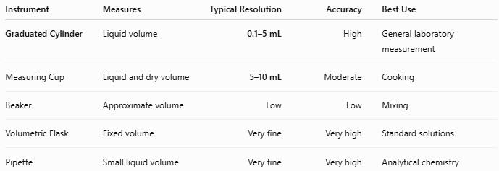
Instrument | Measures | Typical Resolution | Accuracy | Best Use
Graduated Cylinder | Liquid volume | 0.1–5 mL | High | General laboratory measurement
Measuring Cup | Liquid and dry volume | 5–10 mL | Moderate | Cooking
Beaker | Approximate volume | Low | Low | Mixing
Volumetric Flask | Fixed volume | Very fine | Very high | Standard solutions
Pipette | Small liquid volume | Very fine | Very high | Analytical chemistry

Care and Maintenance
# Source: AI Source: Provided by: [Data Path: Persons Table -> ID Column: 1, Name_En Column: Motasem Essam] -> From: [ChatGPT] on [7/17/2026]
To maintain accuracy:
- Wash immediately after use.
- Avoid scratching graduation marks.
- Store upright.
- Protect glass cylinders from impact.
- Verify calibration periodically in regulated laboratories.

Common Mistakes
# Source: AI Source: Provided by: [Data Path: Persons Table -> ID Column: 1, Name_En Column: Motasem Essam] -> From: [ChatGPT] on [7/17/2026]
- Reading from above or below eye level.
- Reading the top instead of the bottom of the meniscus.
- Holding the cylinder while reading.
- Using a graduated cylinder to prepare highly precise standard solutions instead of a volumetric flask.
- Using the wrong cylinder size, reducing reading precision.

Key Points
# Source: AI Source: Provided by: [Data Path: Persons Table -> ID Column: 1, Name_En Column: Motasem Essam] -> From: [ChatGPT] on [7/17/2026]
- A Graduated Cylinder is designed for accurate liquid volume measurement.
- Common types:
  - Glass Graduated Cylinder
  - Plastic Graduated Cylinder
  - Hexagonal Base Graduated Cylinder
- Typical units:
  - mL
  - L
- Common capacities:
  - 10 mL to 2000 mL
- Can also determine the volume of irregular solids using water displacement.
- It is one of the most commonly used measuring instruments in science laboratories.

Conclusion
# Source: AI Source: Provided by: [Data Path: Persons Table -> ID Column: 1, Name_En Column: Motasem Essam] -> From: [ChatGPT] on [7/17/2026]
A Graduated Cylinder is a fundamental laboratory instrument for measuring the volume of liquids with significantly greater accuracy than everyday containers such as beakers or measuring cups. Its graduated scale, transparent construction, and wide range of available capacities make it an essential tool in scientific research, education, healthcare, pharmaceuticals, and industrial laboratories. In addition to measuring liquids, it is widely used for determining the volume of irregular solids through the displacement method, making it one of the most versatile and frequently used instruments for volume measurement.

